Manufacturing Operational Insights Report
Dockerized Sports Analytics Application

  - Course Name: Data Analytics

Institution Name: Medicaps University – Datagami Skill Based Course

Student Name(s) & Enrolment Number(s):
Sr no | Student Name | Enrolment Number
1 | ABHAY SINGH THAKUR | EN22CS304003
2 | SARTHAK GOKHALE | EN22CS304057
3 | HIMANSHI PORWAL | EN22CS306021
4 | AKASH MUVEL | EN23EE3L1001
5 | PRATHAM JOSHI | EN22CS306037

Group Name: Group 04D11
Project Number: DO-30
Industry Mentor Name:
University Mentor Name:
Academic Year: 2022-2026

Problem Statement & Objectives

1. Problem Statement
In today’s software-driven world, applications are expected to be highly reliable, scalable, and easy to deploy across multiple environments. Modern web applications are typically composed of several independent components such as frontend interfaces, backend services, and databases. Each of these components has its own dependencies, runtime requirements, and configuration settings. Managing these components efficiently across development, testing, and production environments is a major challenge for software teams.
One of the most common issues faced during application development is environment inconsistency. An application may run correctly on a developer’s local machine but fail when deployed to another system or server due to differences in operating systems, library versions, or configuration settings. This issue is often summarized by the phrase “it works on my machine”, which highlights the lack of uniformity across environments.
Traditional deployment approaches rely heavily on manual configuration and setup, where developers or system administrators install dependencies, configure servers, and deploy applications by hand. This process is not only time-consuming but also prone to human error. Even a small configuration mistake can lead to application failures, security vulnerabilities, or downtime. As applications scale and teams grow, this manual approach becomes increasingly inefficient and difficult to manage.
Furthermore, modern software development emphasizes continuous integration and continuous deployment (CI/CD), where code changes are frequently pushed, tested, and deployed. Without automation and standardized deployment mechanisms, achieving CI/CD becomes challenging. Manual deployments slow down the development cycle, reduce productivity, and increase the risk of deployment-related failures.
In the context of MERN-based applications, additional complexity arises from managing multiple services simultaneously. The frontend, backend, and database must communicate seamlessly, and each service must be configured correctly for different environments. Without a unified deployment strategy, ensuring smooth interaction between these services becomes difficult.
Therefore, there is a clear need for a solution that:
- Ensures consistency across environments
- Simplifies application deployment

- Reduces manual effort and configuration errors
- Supports automation and scalability
- Aligns with modern DevOps and cloud-native practices
This project addresses these challenges by implementing a containerized deployment approach using Docker and DevOps methodologies, providing a reliable and standardized way to build, run, and deploy a web application.

2. Project Objectives
The primary objective of this project is to demonstrate how modern DevOps practices can be applied to a web application to achieve consistency, portability, and automation in deployment.
The detailed objectives of the project are as follows:
Primary Objectives
- To design and develop a simple sports service web application that serves as a practical workload for demonstrating deployment strategies.
- To containerize the application using Docker, ensuring that it runs consistently across different systems and environments.
- To eliminate environment-related issues by packaging application code and dependencies together.
Technical Objectives
- To create optimized and secure Docker images following industry best practices.
- To separate application components into independent services for better maintainability.
- To configure the application using environment variables, enabling flexibility across development and production environments.
- To orchestrate multiple services using Docker Compose, allowing the entire application stack to run with a single command.
DevOps & Automation Objectives
- To implement a CI/CD pipeline using GitHub, automating the build and deployment process.

- To reduce manual intervention during application deployment.
- To demonstrate how automated pipelines improve reliability and speed of software delivery.
- To prepare the application architecture for future scalability and cloud deployment.
Learning & Practical Objectives
- To gain hands-on experience with Docker, container orchestration, and DevOps tools.
- To understand real-world deployment challenges and how they are addressed in industry.
- To bridge the gap between application development and infrastructure management.
By achieving these objectives, the project not only delivers a working application but also provides a strong foundation in modern deployment practices used by software companies today.

3. Scope of the Project
The scope of this project is intentionally defined to focus on deployment architecture and DevOps practices, rather than extensive application functionality.
Included in Scope
- Development of a basic web application with frontend and backend components.
- Integration of a database to demonstrate service-to-service communication.
- Containerization of all application components using Docker.
- Use of Docker Compose for local orchestration of services.
- Configuration management using environment variables.
- Automation of build and deployment processes through CI/CD pipelines.
- Design of an architecture that is compatible with future Kubernetes-based deployments.
Excluded from Scope

- Advanced business logic or complex domain-specific features.
- User authentication, authorization, and role management.
- Payment gateways or transaction processing.
- Advanced frontend design and UI/UX optimization.
- Production-grade monitoring, logging, and alerting systems.
Justification of Scope
The scope is deliberately limited to keep the project focused on its core purpose: demonstrating modern DevOps and containerization techniques. Adding complex application features would shift attention away from deployment strategies and infrastructure management, which are the primary goals of this project.
This scoped approach ensures clarity, maintainability, and relevance, making the project suitable for academic evaluation as well as real-world DevOps learning.

Proposed Solution

Overview of the Proposed Solution
The proposed solution aims to overcome the challenges of inconsistent environments, manual deployment processes, and lack of automation by adopting a containerized, DevOps-oriented architecture. Instead of focusing on complex application functionality, the solution emphasizes deployment reliability, portability, and automation, which are critical aspects of modern software systems.
The solution is implemented using a multi-service web application architecture, where each major component of the system is isolated, containerized, and managed independently. By leveraging Docker and related DevOps tools, the solution ensures that the application behaves consistently across development, testing, and deployment environments.
This approach reflects real-world industry practices where applications are treated as workloads, and the primary focus is on how they are built, deployed, scaled, and maintained rather than on the number of application features.

1. Key Features
The proposed solution incorporates several key features that collectively enable a robust and reliable deployment workflow. These features are summarized below without going into implementation-level details:
- Containerization of application components to ensure environment consistency
- Independent frontend, backend, and database services
- Lightweight and optimized Docker images
- Environment-based configuration management
- Stateless backend design to support scalability
- Multi-container orchestration using Docker Compose
- Simplified application startup using a single command
- Automated build and deployment through CI/CD pipelines
- Reduced dependency on manual configuration and setup
- Improved developer onboarding and collaboration
- Cloud-ready and Kubernetes-compatible architecture
These features ensure that the application is easy to deploy, easy to maintain, and aligned with modern DevOps principles.

2. Overall Architecture / Workflow
The overall architecture of the proposed solution follows a layered, container-based design, which separates concerns and promotes modularity. Each layer performs a specific role in the system, and communication between layers is achieved through well-defined interfaces.
2.1 Architectural Design
The system is divided into three primary layers:
Frontend Layer
The frontend layer is responsible for handling user interactions and presenting data to the user. It acts as the entry point to the system and communicates exclusively with the backend layer through HTTP-based REST APIs. The frontend does not directly interact with the database, which ensures better security and separation of concerns.

The frontend is designed to be lightweight and stateless, making it suitable for containerized deployment and horizontal scaling if required.
Backend Layer
The backend layer serves as the core processing unit of the application. It exposes RESTful endpoints that handle incoming requests from the frontend and process sports-related data. The backend is designed following stateless service principles, meaning it does not store session-specific information locally. This design choice improves scalability and reliability in containerized environments.
The backend communicates with the database layer through internal container networking, ensuring secure and efficient data access.
Database Layer
The database layer is responsible for persistent data storage. It stores sports-related information required by the backend service. Running the database as a separate container ensures data persistence, isolation, and independent lifecycle management.
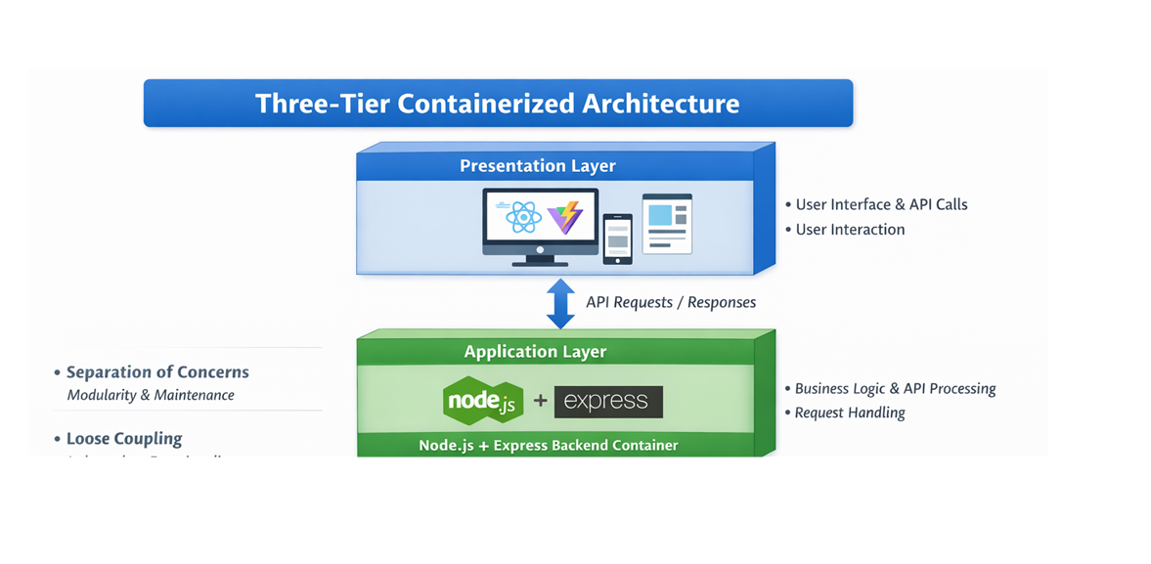

2.2 Container-Based Workflow
Each layer of the architecture is packaged into its own Docker container. This ensures that the application code, dependencies, and runtime environment are bundled together, eliminating inconsistencies across different systems.

Docker Compose is used to define and manage the relationship between these containers. It allows all services to be started, stopped, and monitored collectively. Docker’s internal networking enables seamless communication between containers without exposing unnecessary services to the external network.

2.3 Development Workflow
- Developers write and modify application code locally.
- Code changes are committed and pushed to a GitHub repository.
- The local development environment uses Docker Compose to run all services consistently.
- Developers can test the complete application stack using a single command.

This workflow ensures faster development cycles and reduces environment-related issues.
2.4 Deployment Workflow
- A code push to the GitHub repository triggers the CI/CD pipeline.
- The pipeline builds Docker images for the application services.
- Images are validated and prepared for deployment.
- The containerized application is ready to be deployed to staging or production environments.
This automated workflow minimizes human intervention and improves deployment reliability.

3. Tools & Technologies Used
The solution leverages a carefully selected set of tools and technologies that are widely used in industry and well-suited for DevOps-based application deployment.
3.1 Frontend Technologies
- React: Used to build a modular and component-based user interface.
- Vite: Provides a fast development server and optimized build process.

- CSS: Used for basic styling to keep the frontend lightweight and simple.

3.2 Backend Technologies
- Node.js: Acts as the runtime environment for executing backend logic.
- Express.js: A minimal and flexible framework for building RESTful APIs.

3.3 Database Technology
- MongoDB: A NoSQL database used for storing sports-related data in a flexible and scalable format.

3.4 Containerization & Orchestration
- Docker: Used to containerize each application component, ensuring portability and consistency.
- Docker Compose: Used to orchestrate multiple containers and manage service dependencies.

3.5 DevOps & Automation Tools
- Git: Version control system for managing source code.
- GitHub: Central repository for collaboration and code management.
- GitHub Actions: Used to implement CI/CD pipelines for automated builds and deployments.

3.6 Development & Testing Tools
- Visual Studio Code: Integrated development environment for writing and managing code.
- Browser / API Testing Tools: Used to validate frontend and backend functionality.

4. Advantages of the Proposed Solution
The proposed solution offers several advantages over traditional deployment approaches:
- Eliminates environment mismatch issues
- Reduces deployment time and effort
- Improves application reliability
- Enhances team collaboration
- Supports scalability and future enhancements
- Aligns with modern cloud-native and DevOps practices

5. Summary of the Proposed Solution
The proposed solution delivers a structured, automated, and scalable deployment framework for a web-based sports service application. By combining containerization, orchestration, and CI/CD automation, the solution ensures consistency across environments and simplifies the entire software delivery lifecycle. The architecture is intentionally designed to be modular, lightweight, and extensible, making it suitable for both academic evaluation and real-world DevOps learning.

Results & Output

Overview of Results and Achievements
The successful execution of this project resulted in a fully functional, containerized web application deployed using modern DevOps practices. The outcomes demonstrate that the proposed solution effectively addresses the challenges identified in the problem statement, particularly those related to environment inconsistency, manual deployment, and lack of automation.
The project outputs validate that the application components—frontend, backend, and database—operate correctly both independently and as an integrated system. Additionally, the automated workflows confirm that the deployment process is reliable, repeatable, and scalable.

The results obtained from this project provide strong evidence that containerization and DevOps methodologies significantly improve application deployment efficiency and reliability.

1. Screenshots / Outputs
This subsection presents the tangible outputs generated during different stages of the project. Screenshots included in the report act as visual proof of successful implementation and system functionality.

1.1 Frontend Application Output
The frontend output demonstrates the successful deployment and execution of the user interface component.

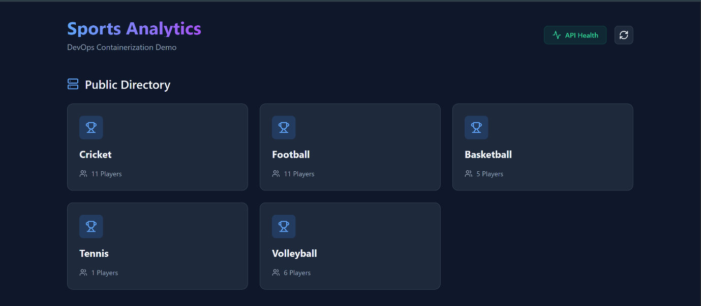
Observed Results:
- The frontend application launches successfully in a web browser.
- The user interface displays the Sports Service homepage.
- The frontend is accessible through the configured local port.
- Data fetched from the backend is displayed correctly on the UI.
Significance:
This output confirms that:

- The frontend build process is successful.
- The frontend container is running correctly.
- Network communication between frontend and backend services is functioning as expected.
The frontend output validates the end-user accessibility of the system and confirms that the presentation layer is operational.

1.2 Backend Service Output
The backend output is verified through application logs and API responses.
Observed Results:
- Backend server starts without errors.
- Console logs confirm successful server initialization.

- Health check API returns a valid response.
- Sports data APIs return correct JSON responses.
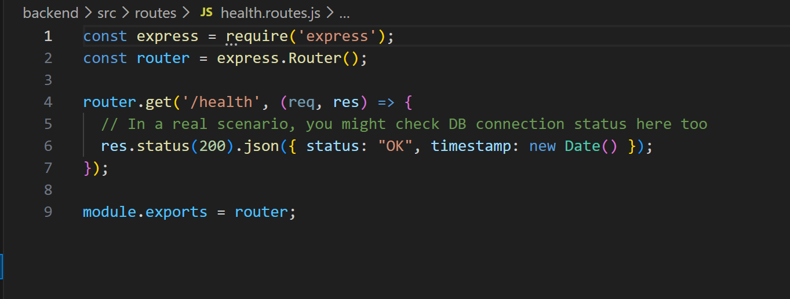
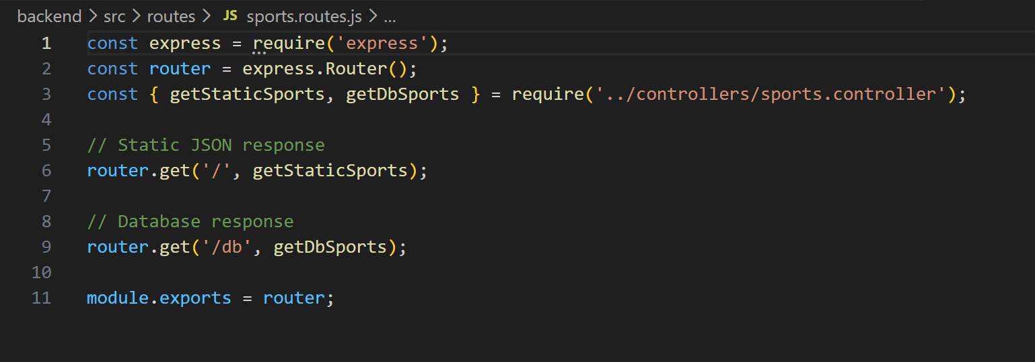
Significance:
These outputs confirm that:
- The backend service is correctly containerized.
- API endpoints are accessible and responsive.
- Application logic is functioning as intended.
This ensures that the backend is stable, reliable, and ready to handle frontend requests.

1.3 Database Integration Output
Database output is verified through successful data storage and retrieval operations.
Observed Results:
- Database connection is established successfully.
- Data records are stored persistently.
- Backend APIs retrieve data from the database without errors.
Significance:
This demonstrates:
- Successful backend-to-database communication.
- Correct configuration of database services.
- Data persistence across application restarts.
The database output confirms that the data layer is properly integrated into the system architecture.

1.4 Docker & Container Outputs

Docker-related outputs provide evidence of successful container orchestration.
Observed Results:
- All application containers run simultaneously.
- Containers start using a single orchestration command.
- Logs confirm healthy container states.
- Containers communicate via internal networking.

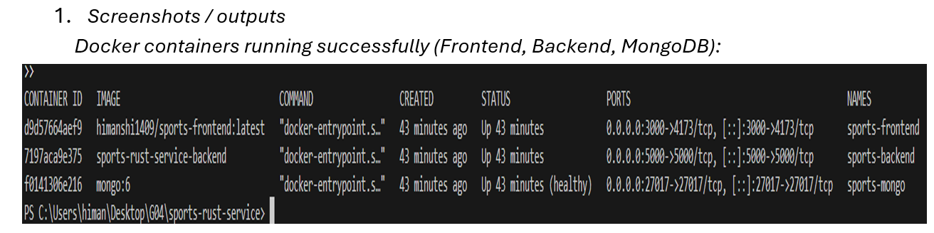
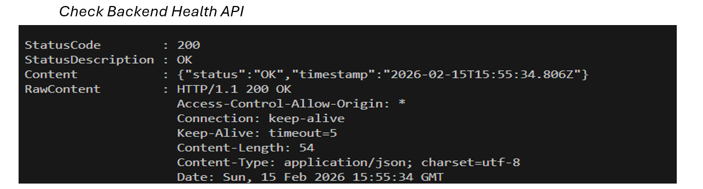
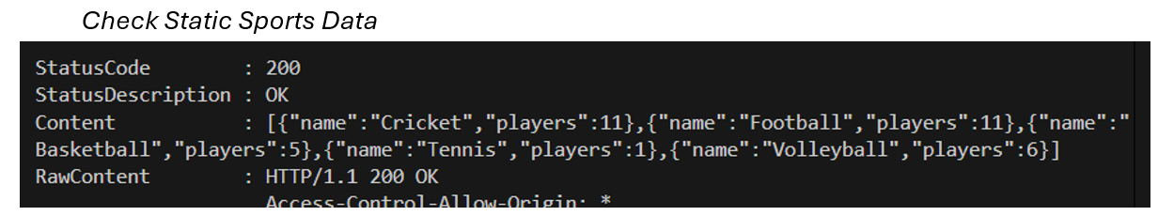
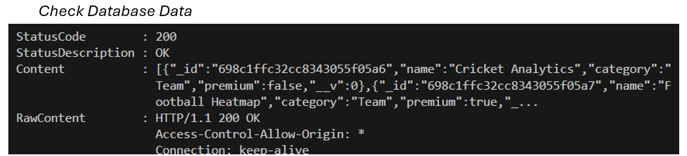

Significance:
These results validate:
- Proper container configuration.
- Correct service dependency management.
- Reliable orchestration using Docker Compose.
This output confirms that the entire application stack is portable and environment-independent.
1.5 CI/CD Pipeline Output
The CI/CD pipeline outputs demonstrate successful automation of the deployment process.
Observed Results:
- Automated pipeline triggers on code changes.
- Build steps execute without manual intervention.
- Docker images are created successfully.
- Pipeline completes with success status.
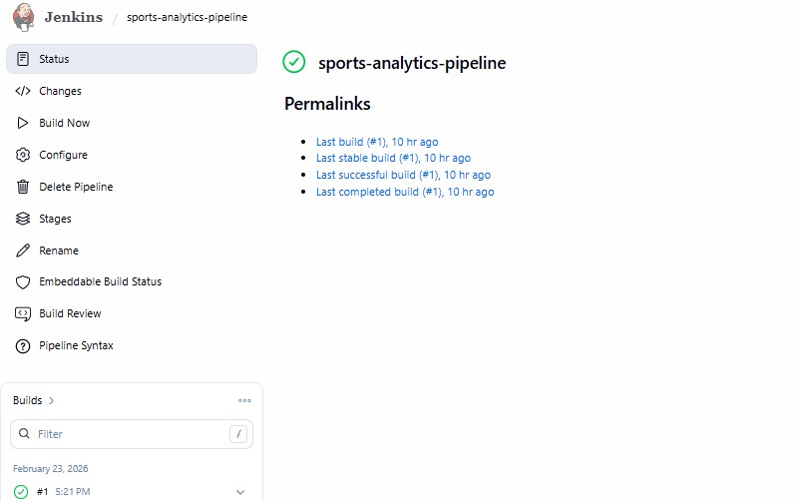
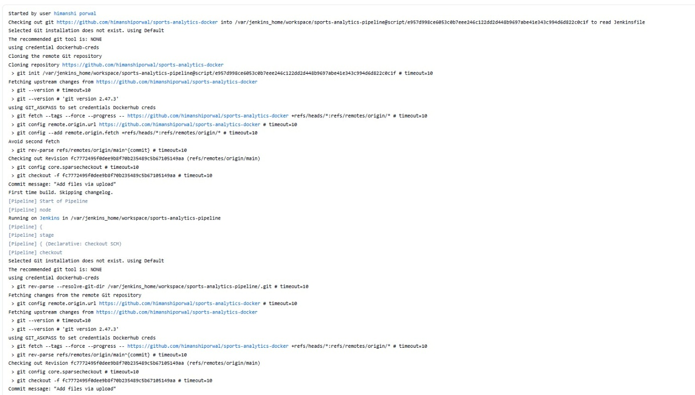
Significance:
These outputs confirm:
- Effective automation of build and deployment workflows.
- Reduced reliance on manual processes.
- Improved deployment consistency and reliability.
This validates the integration of DevOps automation into the project.

2. Reports / Dashboards / Models
While the project does not implement complex analytical dashboards, it generates several operational outputs that act as effective monitoring and reporting mechanisms.

2.1 Deployment and Build Reports
CI/CD pipeline logs serve as deployment reports.
Details:
- Logs record build start and completion times.
- Image creation and verification steps are documented.
- Errors and warnings, if any, are clearly displayed.

Importance:
These reports:
- Improve traceability.

- Simplify debugging.
- Enhance deployment transparency.

2.2 Container Status and Runtime Monitoring
Container runtime outputs act as operational dashboards.
Details:
- Running container lists indicate service health.
- Container logs provide runtime insights.
- Restart behavior validates container resilience.
Importance:
These outputs help monitor:
- Service availability.
- Application stability.
- Resource usage behavior.

2.3 Application Logs as Runtime Reports
Backend and application logs function as runtime reports.
Details:
- API access logs confirm request handling.
- Database operation logs validate data flow.
- Error logs assist in troubleshooting.
Importance:
These logs are essential for:
- Debugging issues.

- Performance validation.
- Operational monitoring.

2.4 Configuration and Environment Models
Environment variable files and configuration files act as deployment models.
Details:
- Separate configurations for development and deployment.
- No hardcoded sensitive data.
- Easy adaptability to different environments.
Importance:
These models demonstrate:
- Secure configuration management.
- Deployment flexibility.
- Industry-standard practices.

3. Key Outcomes
The project achieved several important outcomes across technical, operational, and learning dimensions.

3.1 Technical Outcomes
- Successful deployment of a multi-service application.
- Reliable communication between services.
- Stable runtime behavior across environments.
- Optimized container images and startup times.

3.2 DevOps Outcomes
- Automated build and deployment workflows.
- Elimination of environment-specific issues.
- Reduced deployment errors.
- Faster iteration and testing cycles.

3.3 Operational Outcomes
- Simplified application startup and shutdown.
- Easy scaling potential.
- Improved maintainability and manageability.
- Clear separation of concerns across services.

3.4 Learning and Skill Outcomes
- Practical exposure to Docker and container orchestration.
- Hands-on experience with CI/CD pipelines.
- Understanding of real-world DevOps challenges.
- Improved problem-solving and deployment skills.

3.5 Overall Project Impact
The project successfully demonstrates the application of modern DevOps practices in deploying a web application. It bridges the gap between development and deployment by providing a structured, automated, and scalable solution. The outcomes clearly show that containerization and automation significantly enhance deployment reliability and efficiency.

Summary of Results
In conclusion, the results and outputs of this project confirm that the proposed solution meets all defined objectives. The application runs successfully in a containerized environment, deployment workflows are automated, and system behavior remains consistent across environments. These results validate the effectiveness and practicality of the proposed DevOps-driven solution.

Conclusion
This project successfully demonstrates the practical implementation of modern DevOps and containerization practices through the development and deployment of a web-based sports service application. The core objective of the project was to address common challenges associated with traditional application deployment, such as environment inconsistency, manual configuration, and lack of automation. These challenges were effectively mitigated by adopting a container-based deployment approach using Docker and related DevOps tools.
The project involved the design and implementation of a multi-tier application architecture consisting of a frontend, backend, and database. Each component was developed independently and then containerized to ensure that application code, dependencies, and runtime environments were packaged together. This approach eliminated system-specific dependency issues and ensured consistent application behavior across different environments, including development and deployment setups.
Docker Compose played a crucial role in orchestrating multiple services, enabling seamless communication between containers and simplifying application lifecycle management. The ability to start and manage the entire application stack using a single command significantly improved deployment efficiency and reduced operational complexity. This orchestration approach reflects real-world industry practices where microservices and multi-container applications are commonly used.
The integration of CI/CD pipelines further strengthened the deployment workflow by introducing automation into the build and deployment process. Automated pipelines reduced the risk of human error, improved deployment reliability, and enabled faster iteration cycles. This aspect of the project provided valuable insight into how continuous integration and deployment contribute to improved software quality and delivery speed in professional environments.
From a learning perspective, this project offered extensive hands-on experience with Docker, container orchestration, and DevOps automation. It enhanced understanding

of how development and operations work together in modern software engineering practices. The project also emphasized the importance of designing applications with scalability, maintainability, and deployment considerations from the initial development stages.
In addition to technical skills, the project improved problem-solving abilities by requiring the identification and resolution of real-world deployment issues. Challenges related to configuration management, service communication, and tooling were

addressed through structured troubleshooting and experimentation, leading to a deeper understanding of system behavior in containerized environments.
Overall, this project successfully fulfills its objectives by delivering a robust, automated, and scalable deployment solution. It demonstrates how DevOps practices can be effectively applied to modern web applications and serves as a strong foundation for future learning in cloud computing, container orchestration, and large-scale system deployment. The knowledge and experience gained through this project are directly applicable to industry environments, making it a valuable contribution to both academic learning and professional skill development.

Future Scope & Enhancements

Overview
Although the current implementation of the project successfully demonstrates containerization, orchestration, and DevOps automation for a web-based sports service application, there are several opportunities for future improvement and expansion. The project has been intentionally designed with a modular and scalable architecture, making it well-suited for future enhancements without requiring major changes to the existing system.
The future scope of this project extends beyond its current academic implementation and aligns with real-world industry practices, where applications continuously evolve to meet growing user demands, performance requirements, and security standards.

1. Migration to Kubernetes
One of the most significant future enhancements is deploying the application on Kubernetes.
- Docker containers created in this project are already Kubernetes-compatible.
- Kubernetes can be used to manage container orchestration at scale.
- Features such as automatic scaling, self-healing, and rolling updates can be introduced.
- Kubernetes Services and Ingress can be used to expose the application securely.
This enhancement would make the application suitable for large-scale production environments and cloud-native deployments.

2. Advanced CI/CD Pipeline Enhancements
The current CI/CD pipeline can be extended to include more advanced DevOps practices:
- Automated testing (unit tests and integration tests)
- Static code analysis and linting
- Security vulnerability scanning for Docker images
- Multi-environment deployment (development, staging, production)
- Automated rollback mechanisms in case of deployment failures
These improvements would further enhance deployment reliability, security, and software quality.

3. Monitoring, Logging, and Observability
Another important area for enhancement is the introduction of monitoring and logging systems.
- Centralized logging for backend and container logs
- Monitoring tools to track CPU, memory, and container health
- Alerting mechanisms for service failures or performance issues
- Health dashboards to visualize application status

Implementing observability tools would improve system reliability and help in proactive issue detection.

4. Security Enhancements
Security can be strengthened in future versions of the project through the following measures:
- Secure management of secrets using secret management tools
- Role-based access control (RBAC) for services

- Secure API authentication and authorization mechanisms
- Container image scanning for vulnerabilities
- Network-level security policies between services
These enhancements would make the system more robust and suitable for production environments.

5. Application Feature Expansion
While the current application is intentionally simple, future versions can include additional features such as:
- User authentication and authorization
- Admin dashboards for managing sports data
- Real-time updates using WebSockets
- Advanced search and filtering capabilities
- Integration with external sports data APIs
These features would transform the application from a demonstration workload into a fully functional product.

6. Cloud Platform Deployment
The project can be extended to support deployment on cloud platforms such as:

- AWS
- Google Cloud Platform (GCP)
- Microsoft Azure
Cloud services can be used for managed databases, load balancing, and scalable infrastructure, making the application suitable for real-world enterprise deployment.

7. Performance Optimization
Future improvements can focus on enhancing application performance:
- Load balancing across multiple backend instances

- Caching mechanisms to reduce database load
- Optimized container resource allocation
- Improved frontend build optimizations
These enhancements would ensure better performance under high user load.

8. Improved Configuration Management
Configuration handling can be further improved by:
- Using centralized configuration services
- Supporting environment-specific configuration files
- Managing secrets securely without exposing sensitive data
This would enhance flexibility and security across different deployment environments.

9. Enhanced Documentation and Automation
Future work can also focus on improving documentation and automation:
- Detailed deployment guides
- Automated environment setup scripts
- Infrastructure-as-Code (IaC) implementation

- Automated backup and recovery mechanisms
These improvements would make the project easier to maintain and extend.

Summary of Future Scope
The future scope of this project is extensive and aligns closely with modern industry practices. By incorporating Kubernetes orchestration, advanced CI/CD pipelines, monitoring, security enhancements, and cloud deployment strategies, the project can evolve into a production-ready system. These enhancements would not only improve technical robustness but also provide deeper learning opportunities in cloud computing, DevOps, and large-scale system design.

